
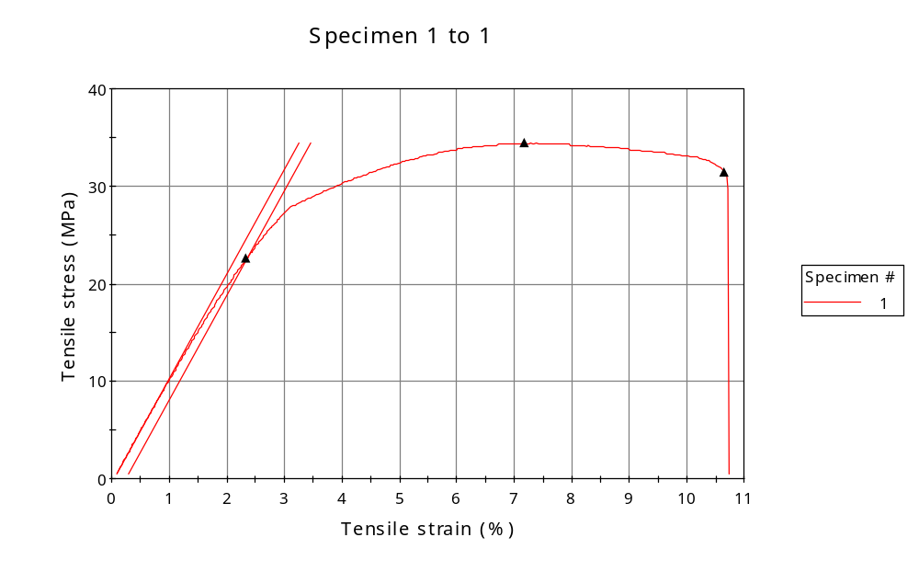
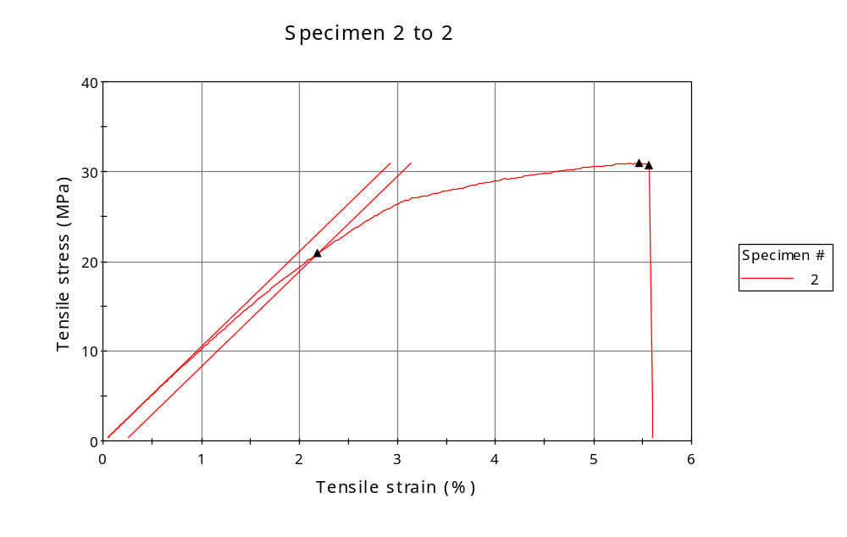
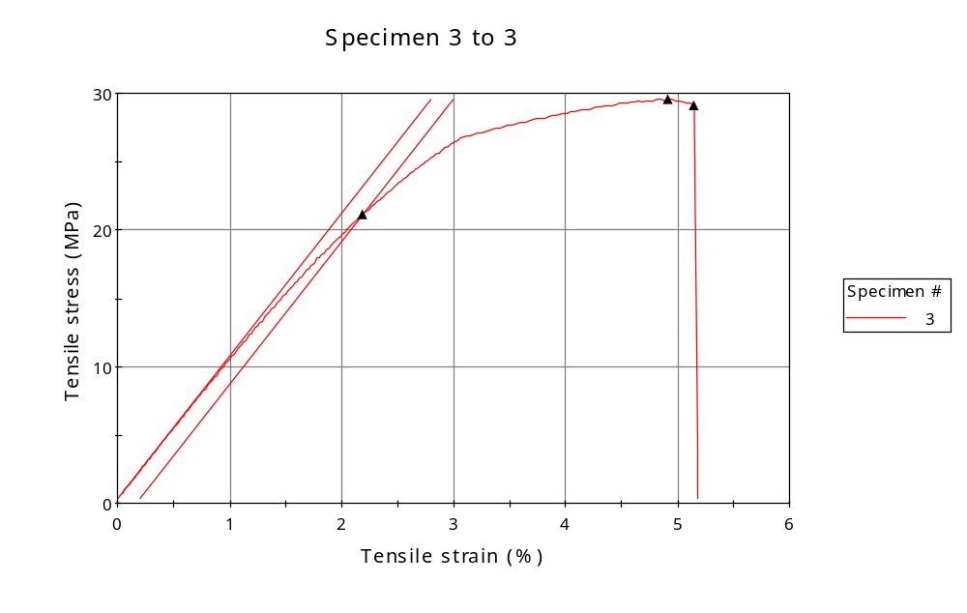
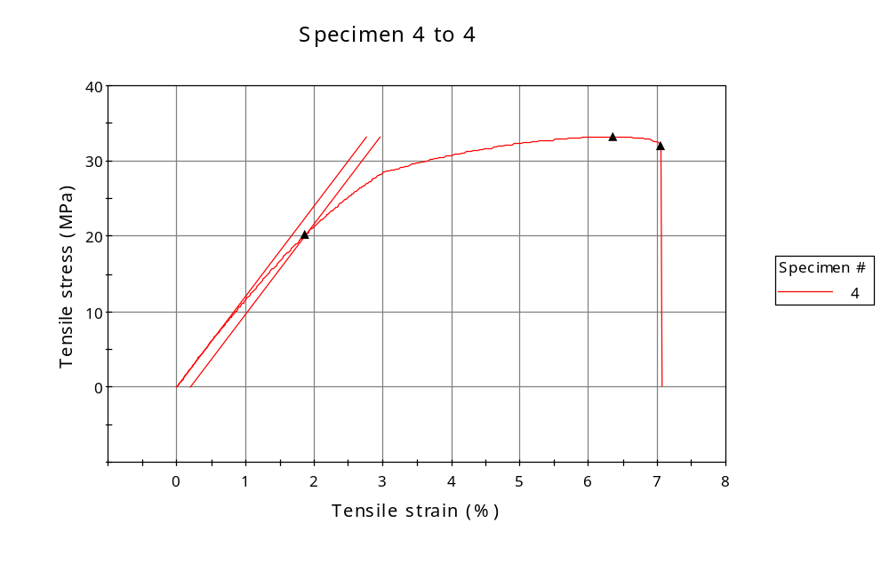
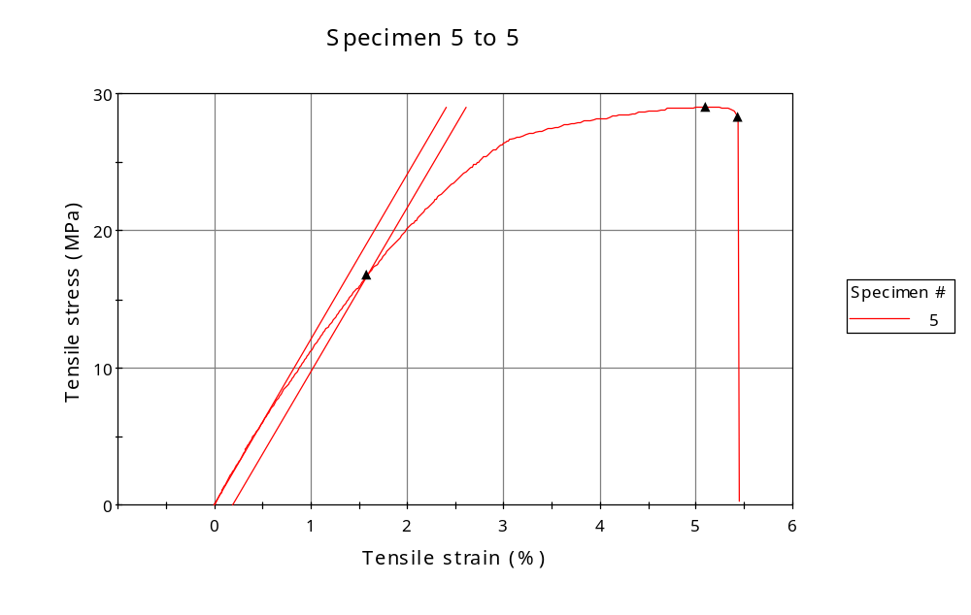
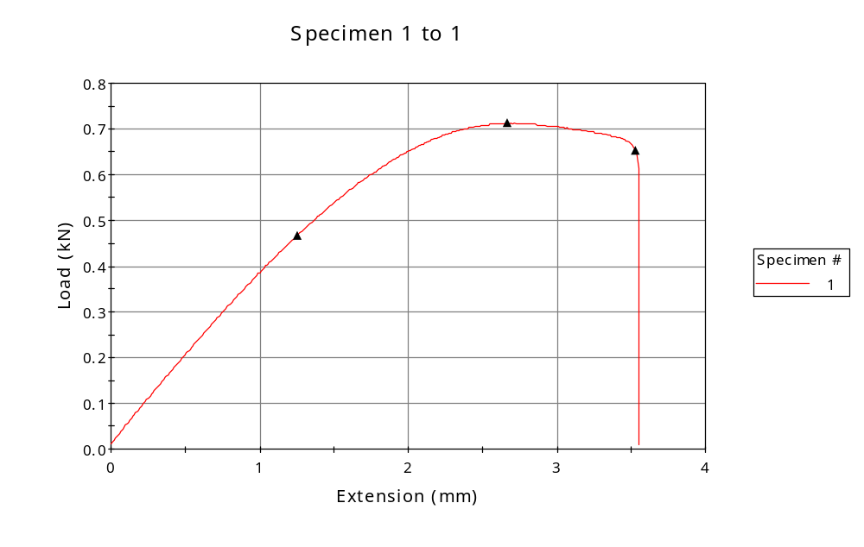
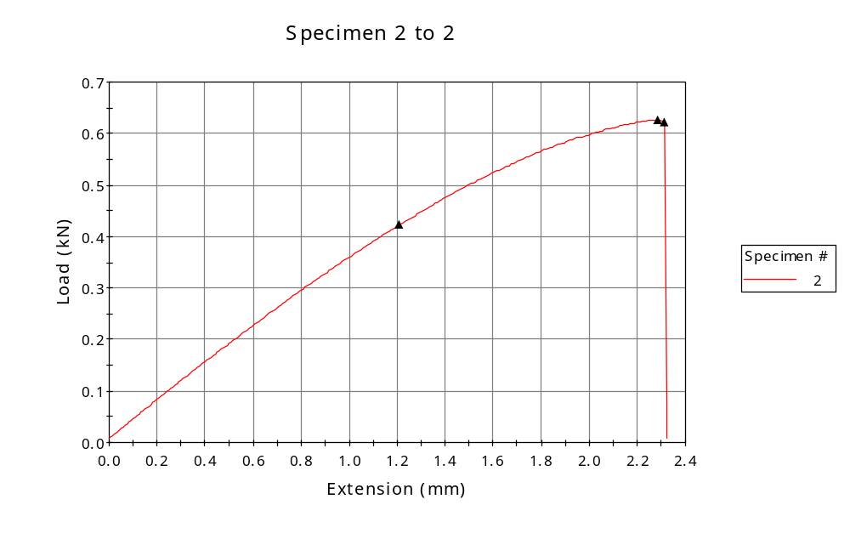
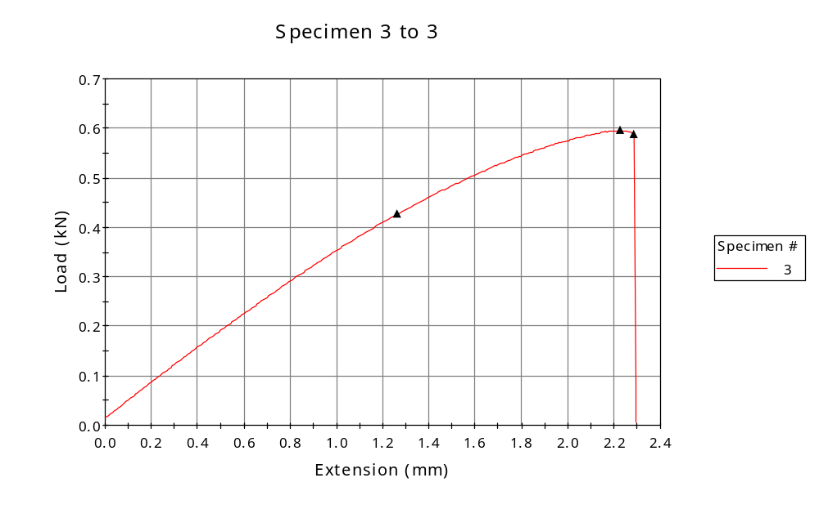
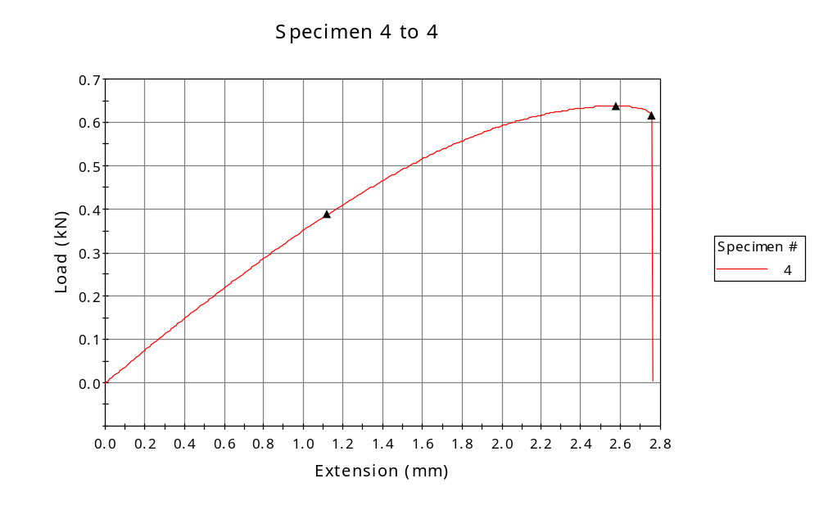
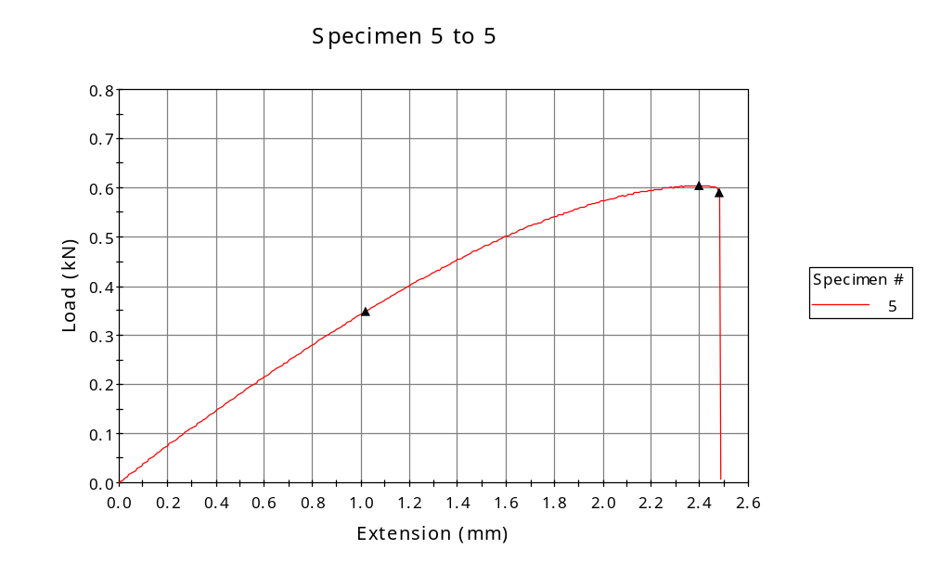

 | CP ID | Length  (mm) | Width  (mm) | Thickness  (mm) | Modulus (Automatic Young's)  (MPa)
1 | CP-FDM_ZY4_01 | 25.00 | 6.18 | 3.35 | 1070
2 | CP-FDM_ZY4_02 | 25.00 | 6.48 | 3.13 | 1057
3 | CP-FDM_ZY4_03 | 25.00 | 6.13 | 3.29 | 1045
4 | CP-FDM_ZY4_05 | 25.00 | 6.00 | 3.20 | 1202
5 | CP-FDM_ZY4_05 | 25.00 | 6.19 | 3.37 | 1196
Maximum |  | 25.00 | 6.48 | 3.37 | 1202
Minimum |  | 25.00 | 6.00 | 3.13 | 1045

 | Load at Fy ( 0.2 %) - LE  (kN) | Tensao em Fy ( 0.2 %) - LE  (MPa) | Deformacao em Fy ( 0.2 %) - LE  (%) | Forca Max  (kN) | Tensao na Forca Max - LR  (MPa)
1 | 0.467 | 23 | 2.340 | 0.712 | 34
2 | 0.423 | 21 | 2.184 | 0.627 | 31
3 | 0.426 | 21 | 2.193 | 0.595 | 30
4 | 0.388 | 20 | 1.874 | 0.638 | 33
5 | 0.349 | 17 | 1.584 | 0.605 | 29
Maximum | 0.467 | 23 | 2.340 | 0.712 | 34
Minimum | 0.349 | 17 | 1.584 | 0.595 | 29

 | Deformacao na Forca Max - LR  (%) | Forca na Forca na Quebra - LQ  (kN) | Deformacao na Forca na Quebra - LQ  (%) | Final length  (mm) | Final width  (mm)
1 | 7.183 | 0.651 | 10.651 | 119.00 | 6.82
2 | 5.465 | 0.622 | 5.565 | 119.00 | 6.82
3 | 4.915 | 0.587 | 5.148 | 119.00 | 6.82
4 | 6.353 | 0.615 | 7.053 | 119.00 | 6.82
5 | 5.100 | 0.590 | 5.433 | 119.00 | 6.82
Maximum | 7.183 | 0.651 | 10.651 | 119.00 | 6.82
Minimum | 4.915 | 0.587 | 5.148 | 119.00 | 6.82

 | Alongamento
1 | 3.76
2 | 3.76
3 | 3.76
4 | 3.76
5 | 3.76
Maximum | 3.76
Minimum | 3.76

